Lark parser toolkit

* Install Lark..

$ pip install lark –upgrade

* Run the following code on terminal…

>>> from lark import Lark

l = Lark('''start: WORD "," WORD "!"

%import common.WORD // imports from terminal library

%ignore " " // Disregard spaces in text

''')

print( l.parse("Hello, World!") )

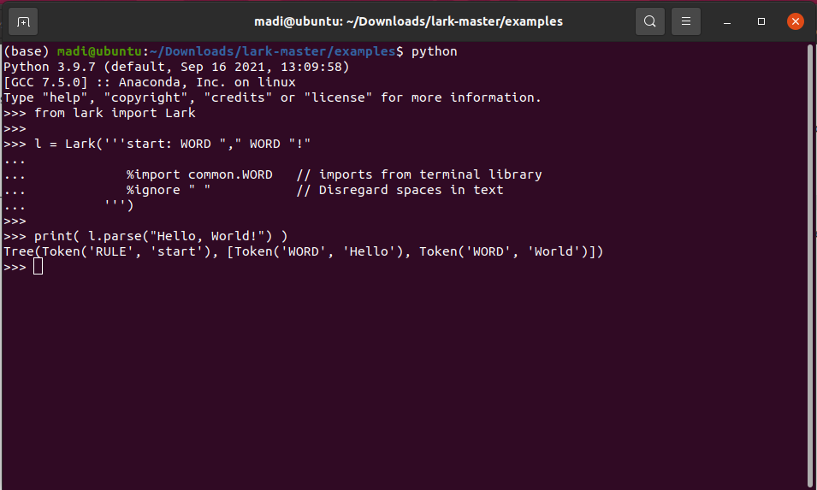

* Notice punctuation doesn't appear in the resulting tree. It's automatically filtered away by Lark.
* Run fruitflies.py …

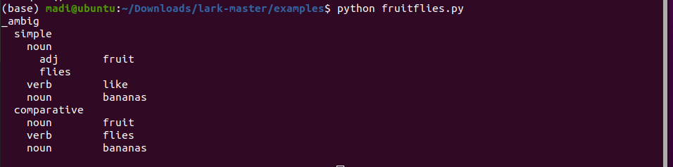

* Run indented_tree.py ….

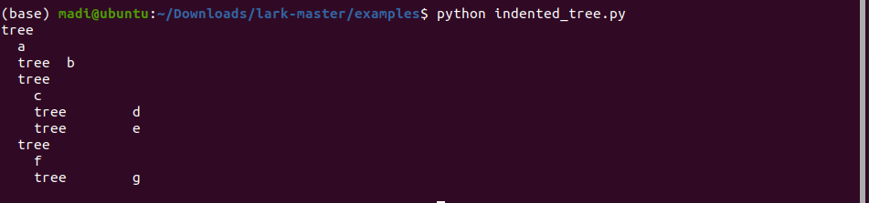

* Reference: <https://github.com/lark-parser/lark>
* Name: Ramah Hashem Madi.